Chapter 6 – Earth’s History Name: ____________________

Lesson: Relative Dating

I Can…/Main Ideas Notes

*Relative Dating*: Determining the ___________ of a rock or event by **_______________** it to the age of other _____________ or _______________

*Absolute Dating*: **_________________** of a rock or an __________ in ___________

*Original Horizontality*: Sediments are **_____________** in **______________ layers**, __________ to the surface of the earth

*Principal of Superposition*: **_______________ ROCK** is found on __________ & the rock age __________________ with **DEPTH**

*Exceptions to the Rules*: **_____________**rock layers & movement along **______________** move __________ rock layers over ______________ layers

_________________ than the rocks in which they occur

INTRUSION: When ____________ squeezes or melts into preexisting rocks & crystallizes.

_______________________________ has altered the rock _______________ & __________________ the igneous mass.

_________________ than any rock it cuts through.

EXTRUSION: Cooling & solidification of ____________ ON the Earth’s surface.

Rock layers ____________________ the igneous mass shows evidence of ________________________________.

_________________ than any rock it cuts through.

The symbol for contact metamorphism is ____________

I can explain the difference between Relative & Absolute Dating

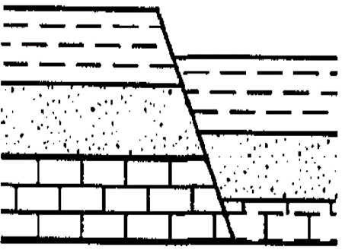I can describe original horizontality & Law of Superposition

**LABEL** THE PICRURE FROM OLDEST TO YOUNGEST!

I can differentiate between the intrusions & extrusions

**Label Pitures!**

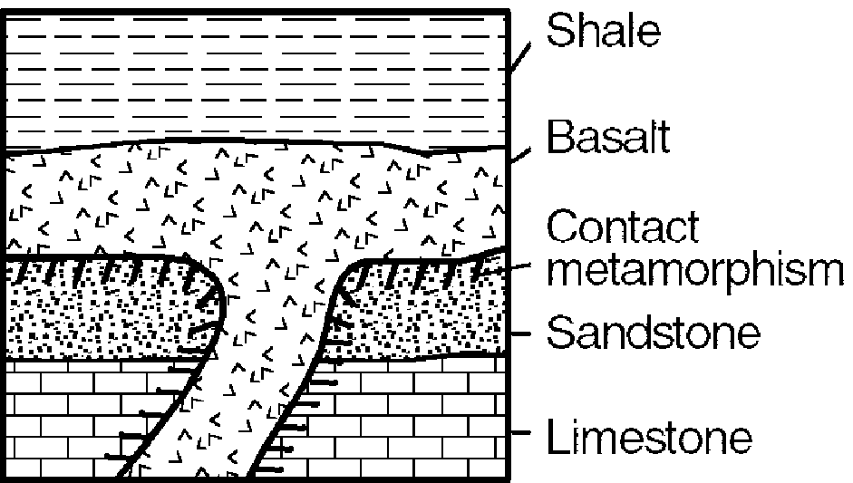

I can describe inclusions & veins

INCLUSION: Body of **_____________** rock ____________an igneous rock and did _________ melt.

VEINS: **_____________ ____________ ____________** which fills a ________ or permeable zone in rock. **____________** than the rock around it

OLDEST: _________

_________________

_________________

_________________

_________________

_________________

_________________

_________________

_________________

_________________

_________________

Correlation: Correlation is used to __________ 2 layers formed at the _________________ but at different _______________

1. Exposed Bedrock - Bedrock is an areas ___________ rock, Usually covered by _______________
2. Similarities in Rocks - Used only in ______________ areas and can still be inaccurate
3. Volcanic Ash: sand & clay sized particles of _______________ rock is shot into the air, and ________________ over wide areas
4. Use of Index Fossils:

* Fossils: _______________________ of former living things
* Normally found in _________________ Rocks
* Index Fossil are ________________________________ and ______________________________

**-**

**-**

Lesson: Correlation

I Can…/Main Ideas Notes

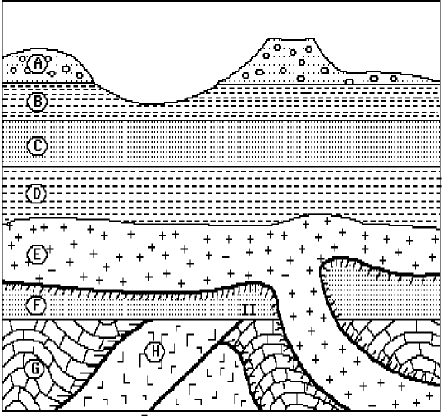*Review*: **Put in order from oldest to youngest**

I can describe correlation & correlate rock layers

I understand what an index fossil is

I can describe unconformities

Unconformities: ________________________ surfaces, Parts of the rock record are ______________, Cause a ______ in the rock record

**

Aim: Radioactive Dating

*Review:*

1. List the layers from oldest to youngest.
2. Name 2 processes that produced the unconformity in outcrop I.
3. Describe the 2 characteristics a fossil must have to be considered a good index fossil.

Absolute Dating – **_________________________** of rocks & other objects

* Examples – Radioactive Decay & Counting Tree Rings

*Isotopes & Radioactive Decay*

Elements – Substance of atoms that are chemically alike

* Elements exist in many forms called ________________________
  + Examples: _____________________________________

Isotopes are ____________________ or __________________________

* Emit (give off) ________________ in a process called radioactive decay
* This occurs until a ______________ isotope forms

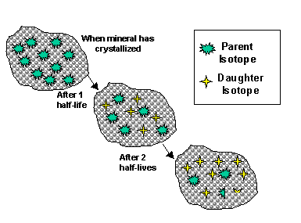Half Life- Time required for ___________ of the atoms in a given mass of an isotope to _____________ or break down.

* Each time you lose ________ of the ____________ isotope & gain ________ of the ______________ isotope.



**OPEN ESRT TO

PAGE ______**

_______________ ________________

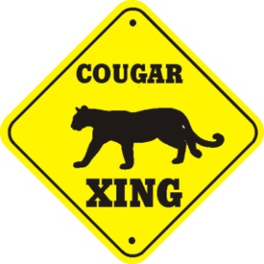

Scientific Notation to a Normal Number

* Count the # of times the **DECIMAL** needs to be moved to **RIGHT for each power of ten and** ADD ZEROS
* Example: 3.5 x 106 = 3,500,000

Carbon-14 –

* ____________ half-life
* Used to date ____________________________________________

Uranium-238-

* ___________ half-life
* Used to date ___________________________________________
* Was used to get the age of the _______________

Shade in the appropriate amount.

Each half-life the parent isotope gets cut in half.

One Half-Life Two Half-Life Three Half-Life

Sample Question-

1. If the amount of carbon-14 in the original sample had been 48 grams, about how much carbon-14 would have been left after 17,100 years?

Lesson: Geologic Time Scale

I Can…/Main Ideas Notes

Broken into ________________ sections by ____________________

- __________________ - ______________

- __________________ - ___________________

Precambrian Eon:

* ________________ eon
* Makes up ____________ of all geologic time
* Started with __________________ of the earth & ended ________ million years ago

Paleozoic Era:

* Development of ___________ in the _______________
* Early _______________ & first _________________
* _________________ formed

Mesozoic Era: The “age of _________________” Most common the ________________

* ___________________ broke up
* 1st ___________________ arrived
* 1st ___________________ plant

Cenozoic Era:

* Dino’s became _______________ but __________________ flourished – “Age of __________________”
* Continents moved to _________________ location
  + _____________ & _____________________ formed

I can read the Geologic History of NYS chart

in the ESRT

I can describe important events that occurred in the different Eon & Era’s

Lesson: Theory of Evolution

I Can…/Main Idea Notes

Theory of Organic Evolution: ___________________ record shows a general trend in _______________ things from _______________ to _______________________

Earliest Fossils = ________________________ organisms (bacteria, fungi, algae, & soft-bodied creatures)

Fossils became more _________________ in _______________ period & later (because nature _______________ the __________)

Organisms appeared in the following order: _________________, _________________, _________________, _________________, _________________

Most of the plants & animals that existed on earth are now ______________

Each major era ends when there is a _________________________ (___________________________)

I can explain the Theory of Organic Evolution

I can state the order of the life on Earth

I can describe what happened to most of life on Earth