Name: _____________________________
Chapter 5 – Section 1: Surface Processes & Landscapes: Water & the Ground
Lesson: Water Cycle
I Can…/Main Ideas Notes
I can label the water cycle
Water Cycle is the model used to show the _______________ & _______________________ of water

About __________ joules/gram are needed to change liquid water into ____________________________. Since energy is ____________ the vapor becomes ________________. The _______________ energy is needed for _________________________.
Runoff - Water that flows ____________ the ________________.
Infiltration - Gravity pulls water ______________ the ground
Water Retention - Precipitation can be ____________ or retained on ______________ as ___________ & ___________ or on _________ & ______________.
Water Budget - __________________ (________________) between the zone of _______________ (_____________ with water) & the zone of ______________ (_______________ filled with water)

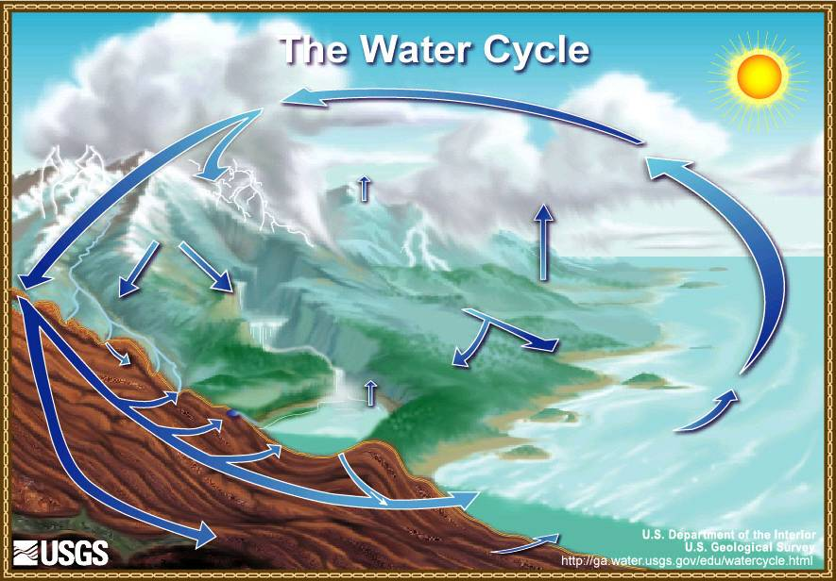

I can state the energy needed to fuel the water cycle

ESRT PG _______

I can contrast the differences between runoff & infiltration

I understand the water budget

Lesson: Factors affecting Infiltration & Runoff

I Can…/Main Ideas Notes
Zone of __________________: Part of Earth’s surface that is FILLED with _________________________
Upper surface (boundary between layers) of this zone is called the ________________________________
Zone of Aeration: -_______________ the water table where particles are filled with _____________ & ______________

Slope of the Land: - STEEPER the slope, the ____________ the Infiltration, Less time to _____________ into the ______________
Degree of Saturation: More __________________ the ground, the ____________ infiltration
Porosity: –Amount of _______________________ between particles
Greater the _____________ the greater the _____________
____________________________ and
______________ material = same porosity

I can divide the earth’s surface into layers

Label the picture
(Zone of Saturation, Zone of Aeration, Water Table)

I can describe the factors that affect infiltration

I can explain porosity

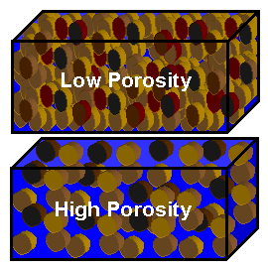

Draw graph for POROSITY of the 3 beakers below.
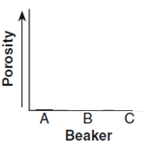
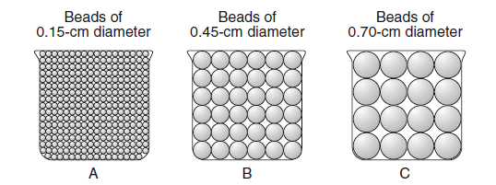

Three Factors that Affect Porosity are:
Shape: _________-rounded particles have______________ porosity
Packing: More _____________ packed the particles, the ______________ the porosity
Sorting: -Material with ________-sorted particles has __________ Porosity

Permeability: Ability of a material to allow fluid to __________ ___________________ it. Materials can be ___________ & yet _______________________
Capillarity -Ability of water to_________ in small openings

-_______________ the particle size, the _____________ the capillarity

Rate of ____________________ > rate of ___________________
Ground is ________% saturated
______________ of the surface is to ____________
Water is not _____________________ fast enough
Vegetation: Ground with __________, ___________, & other plant types have ____________ infiltration
Land use: _________________ surface like __________, ____________________, & buildings _______________ infiltration

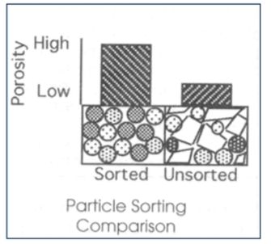

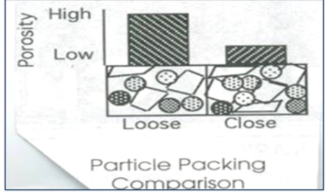
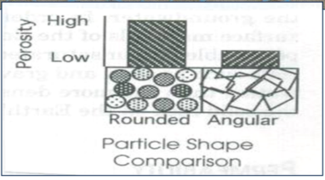

I can describe permeability

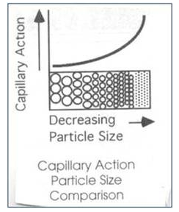

I can define capillarity

I can describe factors that affect runoff

Lesson: Weathering

I Can…/Main Ideas Notes
Weathering is the ______________________ at or near Earth’s surface

I can define weathering

I can differentiate between chemical & physical weathering
Physical Weathering – breaking into smaller pieces

Chemical Weathering- a change in ____________ or chemical composition

Oxidation: when ____________ combines with ____________ to make ______________
Hydrolysis: (Hydro = _____________) Universal _____________, Can _______________ _________ rock materials
Acids: _______________ organic matter mix with ________________ & aid in ________________ rocks
- ____________ combines with ____________________ in the air to form _______________________________
Frost Action: when ____________ gets into _____________ in rocks & _________________ it _______________ & ________________ the rock
Plant root growth: roots_________ into ____________ & _____________ the rock
Abrupt temperature changes: abrupt temperature changes _________
Abrasion: when rock particles______________________ another rock & make it _____________ & _______________
Exposure: The _______________ a rock is to Earth’s surface the _______________ it will weather
Mineral Content: some minerals weather ______________ (limestone – marble) & others weather slowly (_____________) because of their hardness.
I can state examples of chemical weathering

I can state examples of physical weathering

I can describe the factors that affect the rate & type of weathering

Particle Size: When the rock is ____________ there is more ______________ __________ for weathering to occur
Climate: in __________ ___________ climates ______________ weathering occurs more ______________
Soil – formed by _________________ and _____________________

Sediments are ____________________ & _____________________
- ______________& _________________ Earth’s surface
Include:
1) _________________ of EROSION
-_______________ Water, Wave, Currents, ______________, Wind or Human Activity
2) DRIVING ______________________
-_______________________ or Sun
The process by which sediments are ____________________ (__________________________)
_____________________ – releasing of dissolved _______________ from a _______________________________
Factors Causing Deposition
Velocity: __________________
Size: _______________ sediments settle first
Shape: the more ____________ a sediment the faster it will settle out
Density: The _____________ the density the __________ it will settle out
Saturation of Minerals: If a solution is __________ it ______________ hold anymore & the new minerals _______________
DYNAMIC EQUILIBRIUM Rate of ____________________ = Rate of ______________________

I can explain soil formation

Lesson: Erosion & Deposition

I Can…/Main Ideas Notes

I can define erosion

I can name the number one force & number one agent of erosion

I can define deposition & describe factors causing it

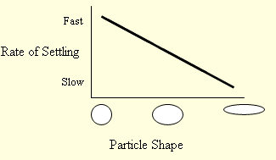

I can describe how dynamic equilibrium is reached

