NAME: _______________________________
Chapter 5 – Section 2: Surface Processes & Landscapes: Oceans, Glaciers, & Environmental Changes

Lesson: Erosion by Glaciers
I Can…/Main Ideas Notes
I can define what a glacier is & describe how they move
Glacier – _____________________________________________ you get a glacier
- Mass of _____________ & ____________ that moves ________________ on _____________ under the influence of ______________________
More snow & Ice accumulates = _____________________________
Less snow & ice accumulates = ______________________________
Glacial movement is by ___________________________________ (Acts like a ________________________)
Movement is fastest in the ______________ & ________ where there is less _______________________
Till: _________________________________________________
Striations: _______________ on bedrock that ____________ the __________________ the glacier was ___________________
____ shaped valleys
_________________ Lakes – Glacial Carved
Moraine: Formed when a glacier ____________ moving
- ______________ sediment ______________ directly from the ___________ or bottom of a glacier
Outwash Plain: Rock material deposited by the _________________ of a glacier which form a broad___________ beyond a __________
Kettle Lake: Formed when a ___________________ of ________ ______________ in glacial sediments _______________
Erratic: a boulder transported and deposited by a glacier that is a _____________ type of rock than the ___________ upon which it is sitting

I can describe different glacial features that form

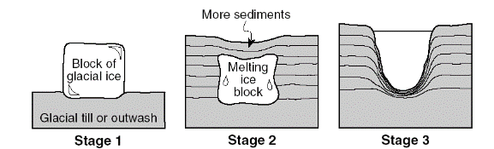

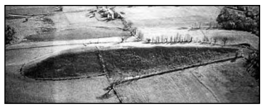
Drumlin: – _________________ mound of _____________ sediments
- Shows the _______________ the glacier was _________________
Lesson: Erosion by Running Water
I Can…/Main Ideas Notes
Most ____________________________ of Erosion
Dissolved Minerals – _____________________________________
Small Sediments – ________________________________ in water
Large Sediments – carried by _________, ___________, or _______________
3 Factors Effecting:
1. _________________ ( ________________________________)
2. __________________ ( _________________)
3. ____________________________________________
______ Gradient = _____ Velocity
______ Slope = _____ Velocity
Kinetic energy _____________ = __________________
- Occurs in regions of ___________________ or _____________________
Kinetic energy _____________ = ___________________
- Occurs in regions of __________________ or __________________
Greater Velocity - ____________________________________ it can _________________
Stream Direction:
Channel is STRAIGHT – MAXIMUM _____________ is in the ___________ of the stream
Channel CURVES – MAXIMUM _____________ shifts to the ________________ of the _______________
DEPTH – greatest velocity is just __________ the _____________ of water.
I can explain how running water transports sediment

I can describe stream velocity

Other factors for stream velocity

Meander
____________________: ___________________ in a river
EROSION & DEPOSITION occur at
1. _____________________ in a stream.
2. Between the _____________ & the ___________ of a stream
3. Stream changes ____________________.

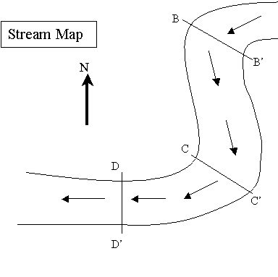
I can illustrate where erosion & deposition takes place on a meandering river
B B’
NOT THE SAME IMAGE AS IN THE VIDEO
LABEL where erosion & deposition are occurring on lines B-B’, C-C’ & D-D’
C C’

DRAW the cross sections (or side views) of what the bottom of the stream would look like at C-C’ & D-D’ (B-B’ was already done for you)
Sorted Sediments: Particles _____________ in ________ ( or ______________, or ____________)

Graded Bedding ____________ Horizontal Sorting: ___________
________________________ __________________________
( ________________) ___________________________
( ________________________)
Picture: Picture:

Oxbow Lake: Curved section of ___________ channel that have been ___________________ by the river
Watershed: Area of _________ _____________ by any one ________________

D D’

I can describe the two main ways running water sorts sediments (write definitions & DRAW the pictures)

I can define features made by a river

V-shaped Valley: ____________ ___________ by stream or riVer
Natural Levee: Gently _____________ deposits created by ___________________ __________________
Floodplain: Nearly __________ land where sediments gets deposited ________________ _________________
Delta: _________________ of sediment where a river ________________ into ________________________ of water

Lesson: Erosion by Mass Movement, Wind, & Waves
I Can…/Main Ideas Notes
Mass Movement – ___________________ & __________________ done directly by __________________.
Examples: ___________________, ____________________, ____________________, _______________________
2 Major Forces:________________________ of _____________ & _________________
Deposition by Mass Movement: sediments are __________________ and ________________
Wind Erosion: _____________ regions, such as deserts, & _______ or ocean _______________ most common
Deflation: – ________________ of landscape by ______________ sand & ______________ sediments.
Sandblasting: (AKA ___________________________)
– Winds blow _____________ or ___________ grains against rocks & other objects
Sand Dunes: – Pile, __________, or _____________ of sand deposited by _____________
- WIND blows _______ the ______________ SLOPE

I can describe erosion by gravity & features that are created.

I can describe erosion by wind & features that are created.

Deposition by Wind

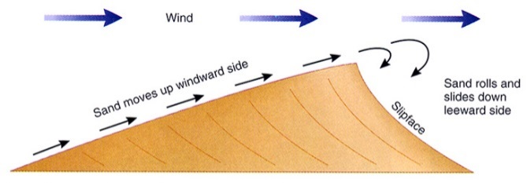

I can describe erosion by waves & features that are created.
Breaking Waves: Waves which become ______________ & _________ water toward the _______________
Waves usually arrive at an ____________ to the shore.
REFRACTED or BENT concentrating _____________ on parts of the shore that _______________ out into the ____________
Longshore Current: Current that move _______________ & ______________ to shore due to ______________ advance of waves
Sandbar: A _____________ or _____________ of sand, often just ___________ or just _____________ water level
Beach – Narrow portion of the ___________ or _____________ between the _________ & ___________ tide lines
Barrier Island- -Long _____________ island, ______________ to the shore
Increase Erosion
- _________________ projects
- Road buildings & ______________________
- _____________________________
- Overgrazing and _________________________
Decrease Erosion:
- ___________________________
- Restore ________________ vegetation
- Set limits on _____________________
- Highways with _______________________________

Stream/Beach – ________________________________________
Glacial – _______________________________________________
Gravity – ______________________________________________
Wind Blown - ___________________________________________

I can describe how people effect erosion

I can describe general characteristics of material deposited by the main types of erosion

