Chapter 4: The Dynamic Crust Name: __________________
Lesson: Earth’s Interior

I Can…/Main Ideas Notes
Explain how
Scientists study through _____________ (_________________) waves
CRUST - ________________ most part of Earth; Mostly ___________ _________________

__________________ Crust - Continents & Larger islands, __________ Ranges (deeper in Mantle), Largely of ______________ (___________ in DENSITY)

Oceanic Crust - Crust beneath the ____________, Composed of ____________ rock (___________ in DENSITY)

_______________ - Below crust is the _________________ zone, Contains _____% of Earth’s volume, Separated by the crust by the _____

LITHOSPHERE -Whole _________ & the ___________ portion of _____________, Divided into ______________

________________________ – Below the Lithosphere, Seismic waves _________________ in VELOCITY, Portion of upper mantle which is __________________________________
OUTER CORE - Has a __________________ nature, ___-waves DON’T PASS through it, Partly creates the Earth’s ______________________
INNER CORE - Extends down to Earth’s ______________, Believed to be a _________________
**BOTH are composed of ____________ & ________________ based on studies of ______________________**

scientists know
about the layers of
the Earth

Name & explain the
two types of crust

LABEL PICTURE
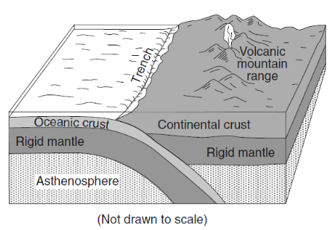
BELOW

Describe the
importance of the
asthenosphere

Compare &
contrast the inner
and outer core

ESRT pg ________

Lesson: Plate Tectonics

I Can…/Main Ideas Notes
The Earth’s ____________________ is broken into sections called ________________ Most accepted theory is that _______________ ________________ in the ________________ drag or push the plates.
What happens to material when it is heated?
When material is heated it becomes ________________ and ________. When the material cools it becomes _______________ and ______________, causing _____________________.
PROOF: ________________ and rocks ______________ (___________) on opposite sides of the _____________, __________________, _______________, & _________________, _________ cycle, _____________ and _____________ change, Major ________________ __________________. Continents look like they ______________________ like _____________________, ___________________ crust is _____________ than the ______________________ crust.
________________________ occur where rising ___________ from the _________________ remains ___________________ while plates move ____________ it, forming progressively ___________ volcanoes; Example - _______________________________
Igneous rocks close to the _____________________________ are __________________ than rocks further away, This is the same for the ________________ flow. Reversal of Earth’s Magnetic Polarity: Earth’s _______________________ flip flop (occurs in _____________________ of years) Magnetic _______________ in the _______________ line up and point to the correct ___________. Currently North America is moving to the ______________________!

What is believed to
make the plates move
DRAW CONVECTION
CURRENTS BELOW
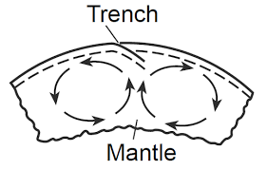

Name proof that the
Earth’s plates have
moved over time

Describe age & heat
patterns located at
the Mid Ocean Ridges

Lesson: Plate Boundaries

I Can…/Main Ideas Notes
Convergent Plate Boundaries: ________ plates __________________
_______________ of the 2 plates ___________ (______________)
Heat and pressure causes ___________________________
Two OCEAN PLATES Ocean ____________ – long
steep narrow _________________ & ___________________________ – some
___________ breaks through the Earth & forms a series of ________
OCEAN & CONTINENTAL PLATES – Young _____________ _____________ – mostly _______________
2 CONTINENTAL PLATES - Form
_____________ mountain ranges
For example - ________________ Mountains
Divergent Plate Boundaries: TWO plates move ______________ & magma _______________, NEW _______________ forms
Continental Plates - Continental ________________, Typically _____km – _______ km wide
Ocean Plates - Mid-ocean ____________ - _____________________ at the bottom of the ocean, Moves ______cm per year
Transform Plate Boundaries: TWO plates ______________ while they _______________________ each other. Lots of ____________ energy ______________ up ______________ energy is released as ______________________
____________________________ in California moves _______cm a year; ______________________ that were split

Convergent plate
boundaries
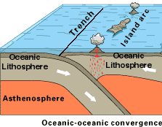

ESRT pg ________

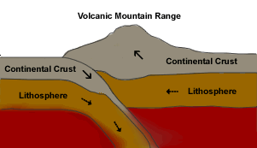
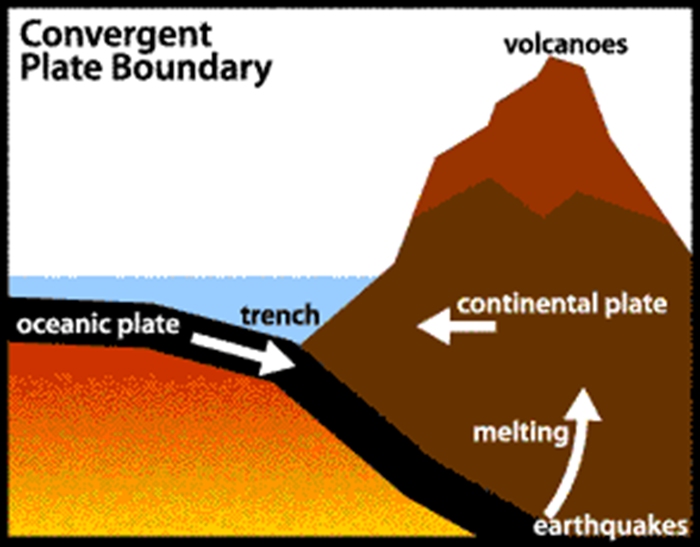

Divergent plate
boundaries

Transform plate
boundaries

ESRT pg ________

Lesson: Earthquakes

I Can…/Main Ideas Notes
-MOST sedimentary rocks show ______________________________
DEFORMED LAYERS - _____________________– RAISED UP Ex: Fossil 100 meters ______________ sea level
___________________ -displaced along a ______________
__________________- ____________ or ______________
LABEL the following pictures as either Fault, Fold, or Uplift.

Earthquake is - Natural rapid shaking of the ____________________ (______________), Releases ________________ stored in rocks
Start at one Point _____________________ earth’s surface where
rock breaks under stress called ___________________. Point
______ surface directly ___________ focus is called ___________________
LABEL focus, epicenter & fault in the picture.

Instruments used to measure earthquake called __________________
The recording is called a ___________________________
Energy of quake is carried through _________________ WAVES
- TYPES: ____ waves, ____ waves, __________ waves
P-Waves – _______________ waves, Vibrate in the ______________ direction, Move through _________ & ____________, ___________ to arrive at epicenter,
Moves _______________

Identify the different
types of crustal
features

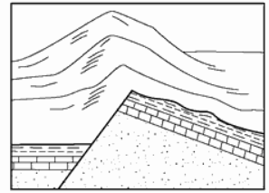
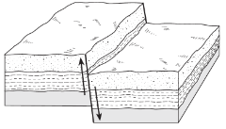
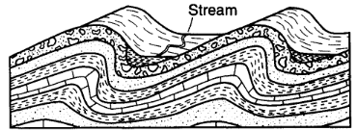

I can describe what
an earthquake is &
where earthquakes
start
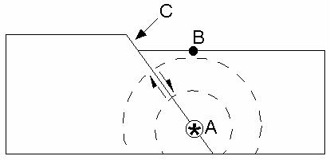

How to measure an
Earthquake

Describe P & S waves

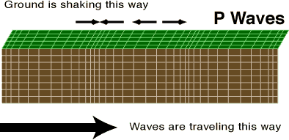

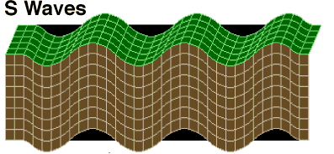
S-Waves - ____________________ waves, Vibrate at _______________________, Move ONLY through ______________, ___________________ to arrive at epicenter, Moves ________________
3 rating scales to measure earthquakes: 1) _______________ scale 2) ___________________ scale 3) ____________________________ scale
Moment Magnitude Scale - _____________ OFTEN used to measure ______________ of earthquake, Use _______________ of wiggles on ___________________ to infer total amount of ______________
Prepare for a future Earthquake - 1) Earthquake _______________
2) Proper _______________ & _________________ of building
During an Earthquake: 1) Stand in a ________________ 2) ________, _____________, ____________
Tsunami - A __________________________ wave caused by an ______________________________________

Scales used to measure
earthquake damage

Earthquake safety

Tsunami

Lesson: Reading P & S Wave Chart
P waves and S waves travel at _________________ ____________, so scientists were able to make travel time graphs.
Time goes by : ____________ Distance goes by: ______________

Q: Seismic station is 2,000 km from epicenter. How long did it take for P-wave to reach there?

S wave travel =

Q: Approximately how long does an earthquake P-wave take to travel the 1st 6500 km after the earthquake occurs?

ESRT pg ________

Q: An earthquake occurred at 5:00:00 am. At what time would the P-wave reach a seismic station 3,000 km from the epicenter?
P-Wave travel time = _____________
Work:

- Reading a Seismogram - P-waves are _________ & __________
- S-waves are _____ & _____________

S – Arrival = ________________
P – Arrival = ________________
Difference = _______________
__________________ the _______________ the _________ away waves are from the Epicenter.

S – Arrival = ________________
P – Arrival = ________________
Difference = _______________

Calculating Epicenter Difference:
- Measure the distance between the start of the first P wave and the start of the first S wave. ______________________
- Use the chart on page 11 and measure the time on the side of the chart with a piece of paper.
- Put a dash at 0 & 6 mins
- Keep moving your paper along the P-wave line until the 6 min dash is on the S-wave line & look down for DISTANCE = _________km

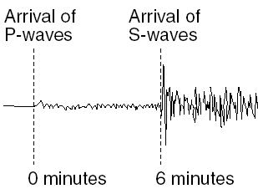
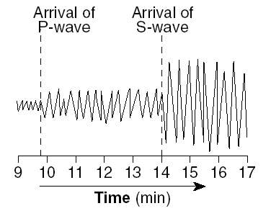
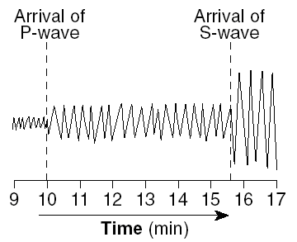
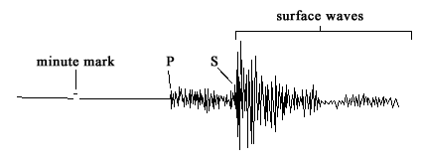
Q: Approximately how far away from Station Y is the epicenter?
Epicenter = _____________________

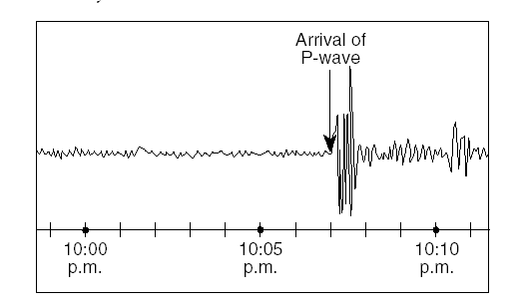
Sometimes they just give you the P-arrival time & ask you for distance.
Difference = ______________
If earthquake occurred at exactly 10:00 pm, approximately how far from the earthquake epicenter was Albany, NY?
1) Find the P-wave travel time on the LEFT of the Chart
DISTANCE = _____________
2) Continue until you get to the P-line & look down to see Distance

Calculate Origin Time
- Origin time is when the earthquake _________________
- It’s determined by the _______________________________ & ____________________________
- The ______________________ the epicenter is, the _________________________ will be between the P and S waves.
Q: P wave arrived at a station at 10 hr: 12 min: 30 sec & the seismograph is 5600 km away from the epicenter, when did the earthquake occur?
10 hr: 12 min: 30 sec
- min: sec

Finding Earthquake Epicenters
- _______ seismic stations must be used
- Each seismic station only tells you the _____________ NOT ___________________!
- Find epicenter distance for each seismograph station
  - Distance is used as a ___________ and circles are drawn on a map
  - Where the ___________ circles ______________ is where the epicenter was
Lesson: Volcanoes

I Can…/Main Ideas Notes
Mountain composed of ______________ ________________ ROCKS
Occur at ______________________________or
_____________________________
Ring of Fire: Boundary around the ________________ Plate, Over ______% of the world's active and dormant ____________ occur here
DURING ERUPTION:
–____________ & _____________ escape onto EARTH’S SURFACE or ATMOSPHERE, Exit through opening or ___________ of a volcano
INTRUSIONS - ____________________ Igneous rocks from __________ stays within the ___________________
EXTRUSIONS - __________________ Igneous rock from ________, _________________________ occur

Dangers - ________________ & ______________ GAS RELEASE: ________________, _______________, & _________ Volcanic ASH: ______________ Sun’s Ray (_________________ of Earth)

SATELLITES - Report on increasing ____________ from magma
TILT METERS - Increased ____________ as volcano ____________ with magma, Monitor INCREASES in 1) _______________, 2) _______________ 3) Number of ____________________
Before - Have a disaster _____________
During - Get to __________ ground & _____________ ___________ poisons gas
After - Cover your ___________ and ___________.
- Wear ______________ to protect your ___________
- Keep your _____________ covered.

A volcano is

What is occurring
during eruptions &
what features are
being formed

Dangers & how to
predict eruptions

Volcano safety

