Topic 1 Note Packet NAME: ______________________
Lesson: What is Earth Science?

I Can…/Main Ideas Notes
Earth science is ______________ sciences rolled into one.

- Means "______________________________________”
- Deals with the ____________________ of Earth materials, Earth ________________, and Earth ___________________.
- How the planet has ___________________ over time.
- Important because:
  - Geologists search for _______________ and _____________
  - Study ______________________________
  - Work to protect Earth's _____________________
- The study of the _____________________ and how processes in the atmosphere determine Earth's ____________________ and ______________________
- Important because
  - _______________________ about the ______________
  - How _________________________________________ in response to the _______________________________
  - Critical concern for ________________________ Earth's ________________________.
- The study of Earth's _____________
- their _______________, _______________, organisms and ______________________.
- Important because –
  - The oceans _____________ most of our _____________ and are important resources for __________ and other ___________________
  - _________________________________.
  - Major influence on the ________________ and changes in the oceans can drive or moderate __________________________.
- The study of the ____________________
- Important because:
  - The moon drives the _________________________________
  - ______________________ have repeatedly devastated Earth's inhabitants
  - Energy from the sun drives our_____________& ___________

Geology

Meteorology

Oceanography

Astronomy

Lesson: Observation, Inference, & Classification

I Can…/Main Ideas Notes
Something detected by one of more _______________________________
Sight, hearing, touch, taste or __________________.
_________________ and ____________________

Improve our ability to make _____________________ and take _______________________

An interpretation of an ________________________
- Make an ______________________
- Happened in the __________________ or ________________

An ____________________ based on _______________________
Observations | Inferences

Observations & inferences are than _________________ or ___________________ by ___________________________
Observations

Instruments

Inference

Prediction

When should you
Use them?

Classification

Lesson: Mass, Volume, Density & Measurement

I Can…/Main Ideas Notes
Expressing an _____________________ with more ___________________
________________________________ to a known __________________
Every __________________________ at least one of these three quantities
Length: ____________________________________________________
Time: ______________________________________________________
Mass: ______________________________________________________

Measurement

Mass
Amount of __________________ in an object
Measured by using a ______________________________________________
**Not the same as _________________ (Mass x Gravity)** Mass never _______ _________________________________________

The amount of __________________________________________
- Volume is measured by using either _______________________________ (ruler) or _________________________________ (graduated cylinder)
Show your work on the examples below.

Volume

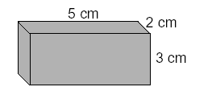
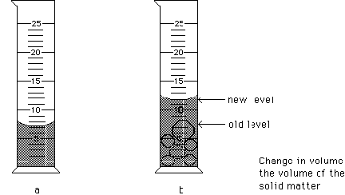

Is the ______________________________________________________
- Or how _______________________ an object is
The density of a material helps to _________________ it from other materials
Fill in the Density Triangle!
Density =
Density of water =
Volume =

Mass =

Density

Density Triangle/
Formulas

Lesson: The Concept of Density

I Can…/Main Ideas Notes
Relative Density is _________________ one density to another and finding an ___________________________

Relative density

For example: Pumice floats in water. What do you think its estimated density is? ____________________________

Density is a ____________ of ____________ to _______________
- If you cut an object in ½ you are reducing the ______________ & _________________ by __________so the density will _______ _____________________

If an object is heated, molecules move __________________________
- Therefore there is _________________ per unit of __________
If an object is cooled, the molecules move ______________________ and density _____________________________.

If pressure ________________ molecules move ________________ ___________________ and mass ______________________
- ___________ mass per unit volume & a ______________ density
_______________________ happens if pressure decreases

Density of a substance changes with changes in its _____________ (___________) of __________________
- Most substances have a higher density as a _____________, because the molecules are ___________________.
The exception to this rule is ______________________.
- Water has its greatest density at ______________.
This is why ice ______________________ in water.

Why density does
not change based on
size or shape.

Temperature affects
density
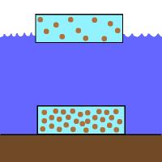
Draw picture above!

Pressure affects
density

Phases of matter
affects density

Lesson: Rate of Change

I Can…/Main Ideas Notes
Independent variable goes on the ________________ (_____________/ ___________________)
Dependent variable goes on the ______________ (_________ / ________________)

Occur in some orderly fashion in which events constantly __________________ & are _______________________
Examples (Name at least 2)
______________________________________________________________________________________________________________
How MUCH a ________ is _______________ (or changed) over a given __________
- Changes can be very ___________ others very _____________

Rate of change = ________________________
Dependent &
independent
variables

Cyclic change

Rate of Change
Formula

(Pg 1 on ESRT)

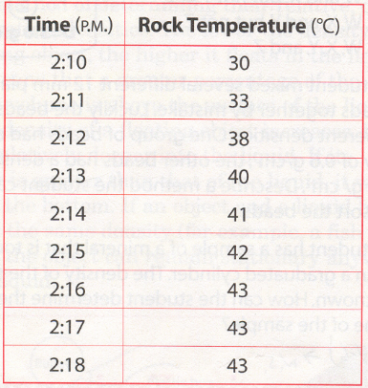
Practice
SHOW YOUR
WORK!

