Name: ___________________________________
Dynamic Crust Review Sheet
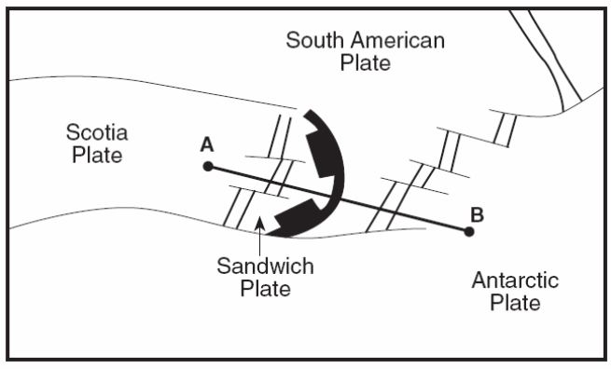
Use the diagram to the right to answer questions 1-2.
1. As you travel from point A to point B, name the plate
boundaries you pass.

2. What is the latitude and longitude of the Sandwich Plate?

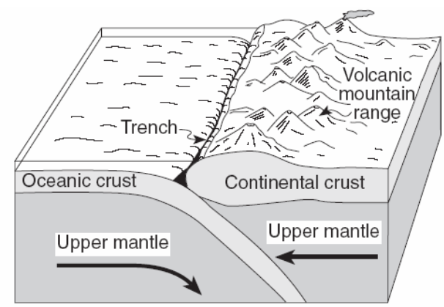
Use the diagram below to answer questions 3-7.

3. What is the density of the oceanic crust?

4. What type of boundary is in the diagram?

5. Label with small X’s where earthquakes
usually occur.

6. What is the specific name of the trench in
the diagram?

7. What type of rocks are most of the continents made of? _________________________________

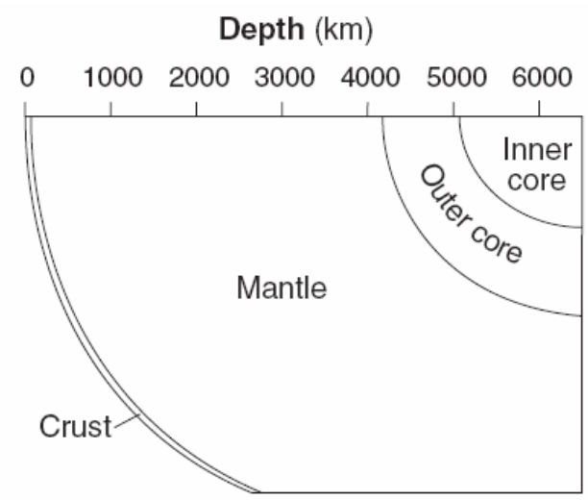
Use the diagram below to answer question 8-12.
8. At what depth below the surface does the inner
core begin?
9. Approximately how thick is the mantle?
10. Which portion of the Earth’s interior prevents or
absorbs an earthquake’s S-wave?
11. Which layer of the Earth’s interior has a density of
9.9-12.1 g/cm³?

12. What is the pressure at the interface between the outer core and the mantle?
Use the diagrams to answer questions 13-15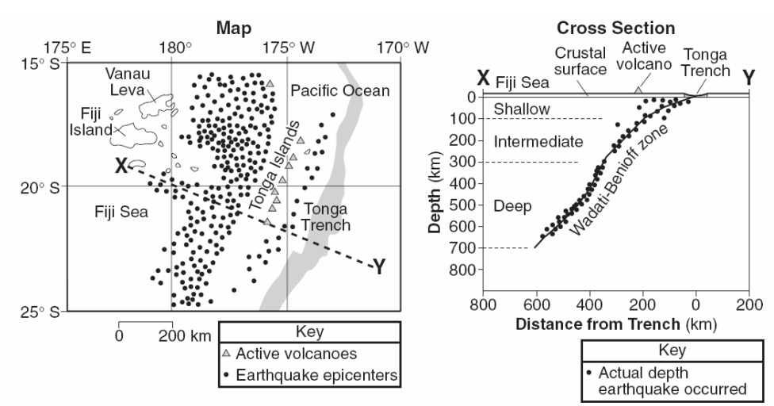
13. How did the Tonga Islands form?

14. Using arrows on the CROSS SECTION picture draw the motion of the plates.
15. Name the two plates on either side of the Tonga Trench at this location.

Use the information below to answer questions 16-19.
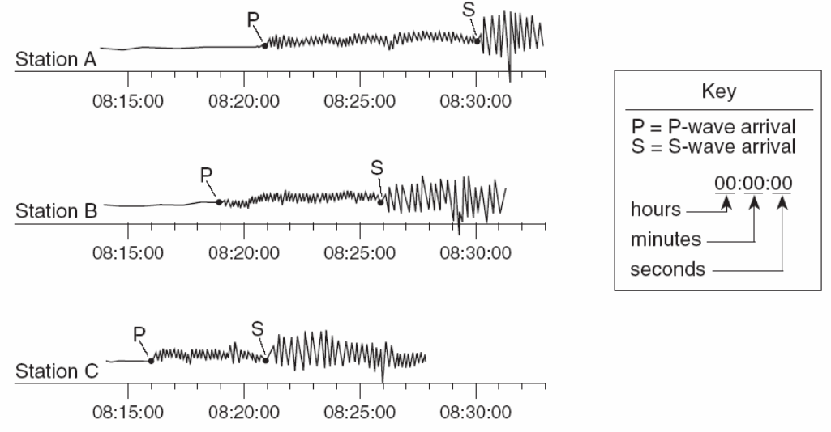
16. What is the difference in
arrival times of the P and S
waves at station A?

17. Which location is closest to
the epicenter?

18. How far from the epicenter
is location B?

19. What is the P-wave travel
time at location C?

20. Fill in the Following Chart.
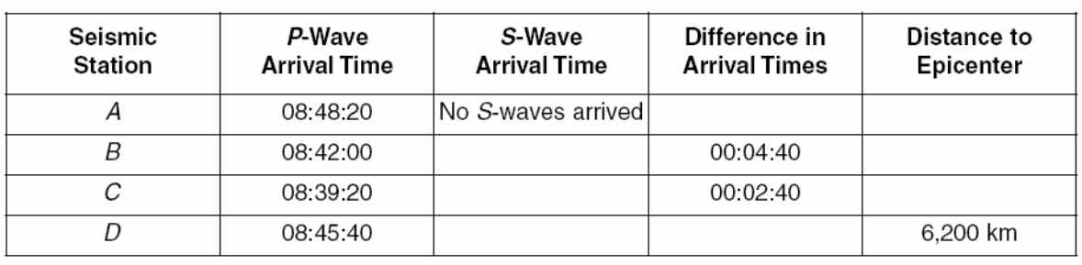
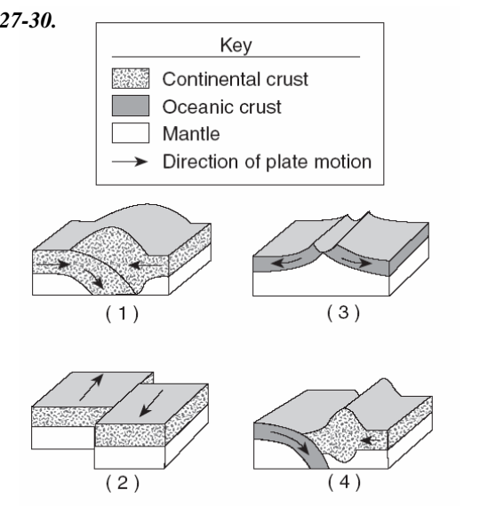
Use the following pictures to answer questions 21-24.
21. Which choice is the Mid-Atlantic Ridge?
22. Which choice is the San Andreas Fault?
23. Which choice is the Peru-Chile Trench?
24. Which choice is the Himalayan Mountains?

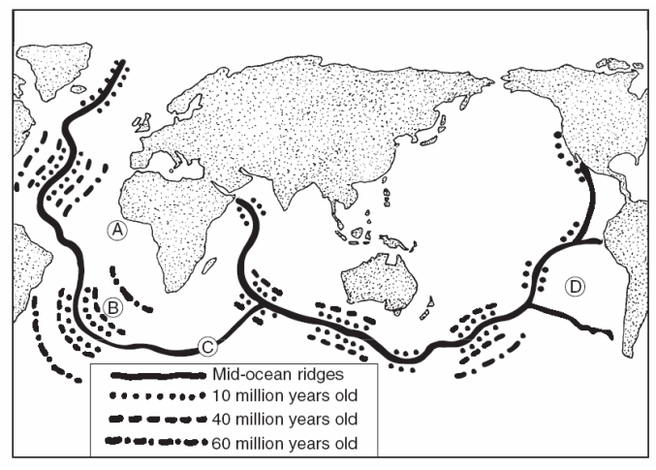
Use the picture to the right to answer questions 25-27.
25. Which location has the youngest rock?

26. What is the approximate age of rock B?

27. Why will A and D have fewer
earthquakes than C?

28. Draw the convection cells on the diagram below.
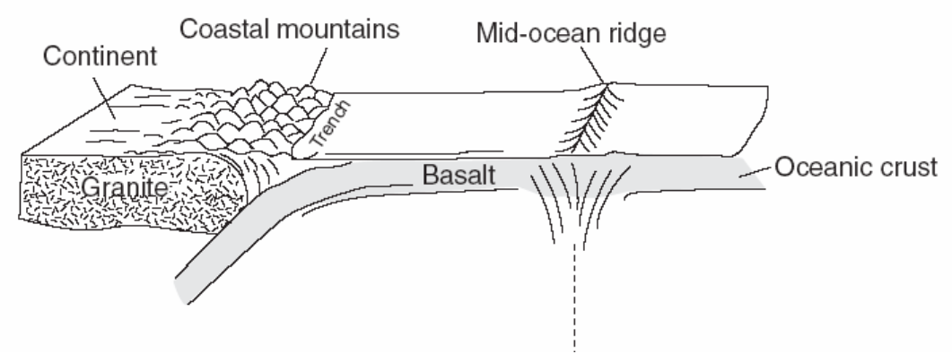

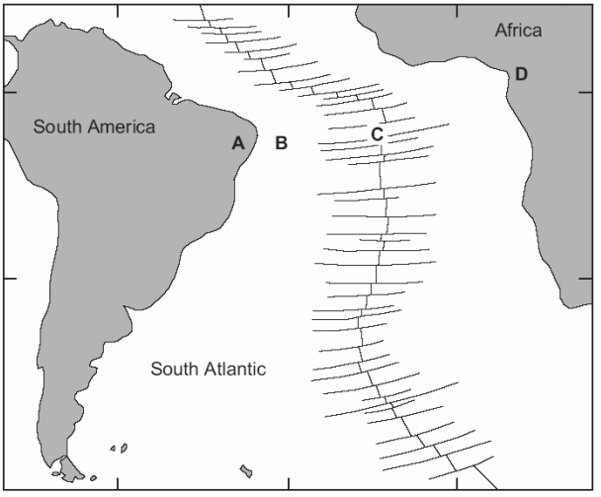
Use the following picture to answer questions 29-32.
29. How does the age of B compare to C?
30. How does the density of A compare to B?

31. What type of boundary is C?

32. What is the name of location C?

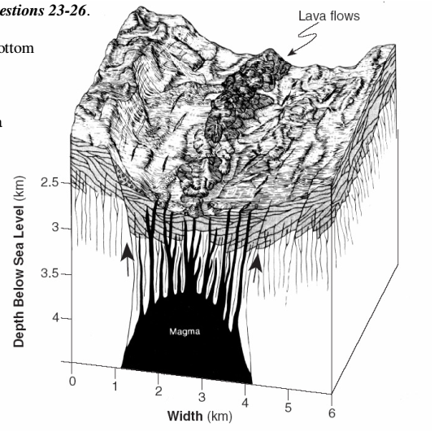
Use the diagram to the right to answer questions 33-36.
33. How thick is the magma near the bottom of
the diagram?

34. What is the difference between lava and magma?

35. If the lave flows are rich in PYROXENE and
OLIVINE, what rock is it?

36. Why does the magma rise?

