Name: _______________________
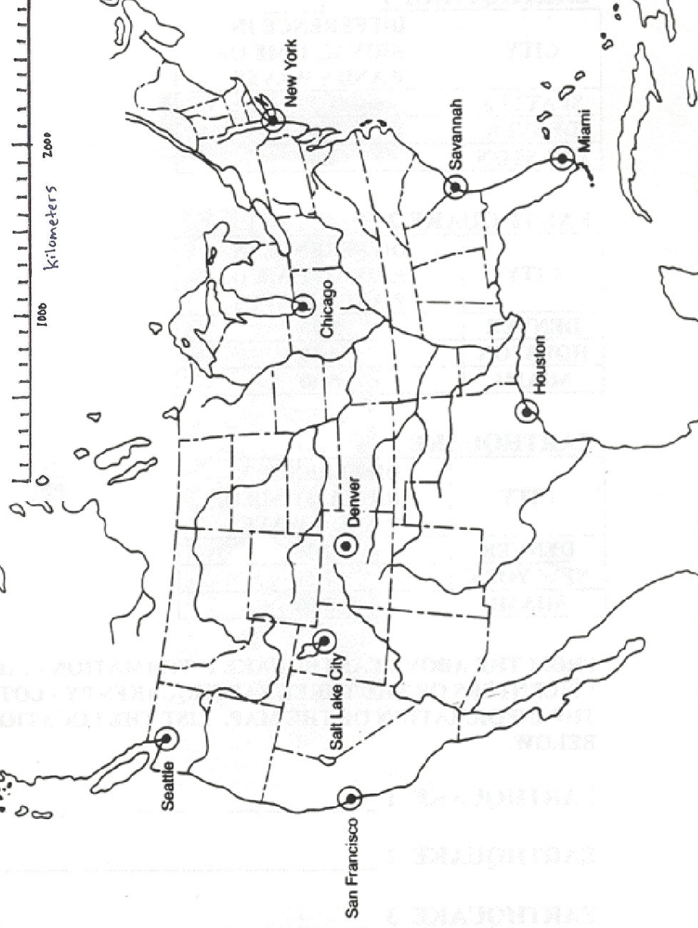
MORE EPICENTER PRACTICE
Practice drawing Possible Epicenter Locations (Circles)
City | Distance
Miami | 500 km
Seattle | 300 km
Houston | 2000 km
Denver | 1,400 km
Chicago | 250 km
NY | 600 km
Savannah | 1,100 km
This is to practice drawing circles you will NOT find the EPICENTER!!

Use the difference in arrival times below to determine the epicenter distances.

Location | Difference in Arrival Times  (min & sec) | Epicenter Distance (km)
San Diego | 2:20
Chicago | 4:40
Seattle | 3:30
New York | 5:00
Boston | 1:50
Wink | 3:10

Determine the scale (how much each line is worth & the Difference in Arrival Times for each seismogram below.
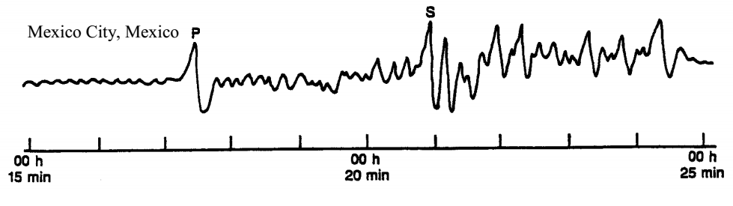
Scale: __________________
Difference in Arrival Time:
_______________________
Scale: __________________
Difference in Arrival Time:
_______________________
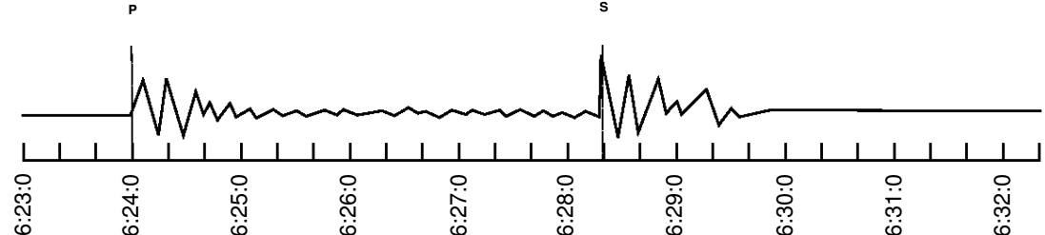
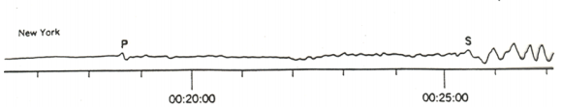
Scale: __________________
Difference in Arrival Time:
_______________________
Scale: __________________
Difference in Arrival Time:
_______________________
Scale: __________________
Difference in Arrival Time:
_______________________

Calculating Eccentricity

Directions: Calculate the eccentricity of the ellipses below. For each, label the Sun at one of the focal points, be sure to write out the equation, show work & round the eccentricity of the ellipse to the nearest thousandth.
Distance between Foci: ______________ (tenth)
Distance of Major Axis: ______________ (tenth)
Formula for Eccentricity & work:

e = __________ (thousandth)
- Place an “X” on the ellipse where the velocity would be the greatest.
- What is the eccentricity of Earth? ___________________
- Compared to the eccentricity of Earth, your ellipse has a __________________________
eccentricity because __________________________________________________________________
_______________________________________________________________________________________
Distance between Foci: ______________ (tenth)
Distance of Major Axis: ______________ (tenth)
Formula for Eccentricity & work:

e = __________ (thousandth)

Rocks & Minerals Review
- Place an “X” on the ellipse where the velocity would be the greatest.
- What is the eccentricity of Earth? ___________________
- Compared to the eccentricity of Earth, your ellipse has a ___________________________
eccentricity because ______________________________________________________
______________________________________________________________________
- Place an “X” on the ellipse where the velocity would be the slowest.
- What is the eccentricity of Mars? ___________________
- Compared to the eccentricity of Mars, your ellipse has a ___________________________ eccentricity because ______________________________________________________ ______________________________________________________________________
Distance between Foci: ______________ (tenth)
Distance of Major Axis: ______________ (tenth)
Formula for Eccentricity & work:

e = __________ (thousandth)

Rock Type | Observable Characteristics
Igneous Rocks
Sedimentary Rocks
Metamorphic Rocks

Cleavage or Fracture?
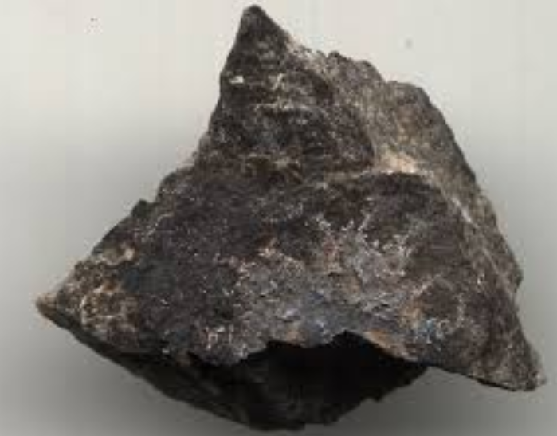 | 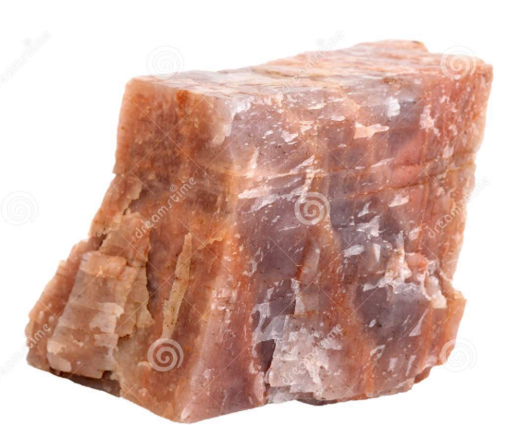
Cleavage OR Fracture | Cleavage OR Fracture
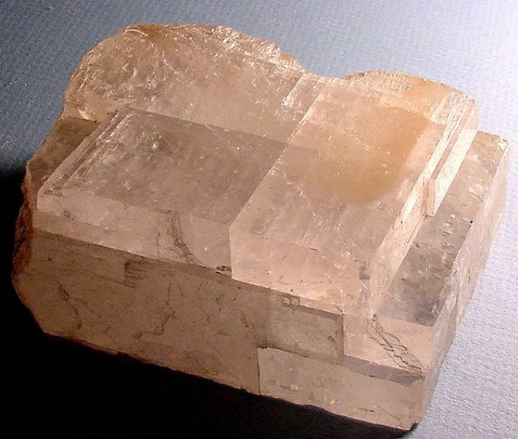 | 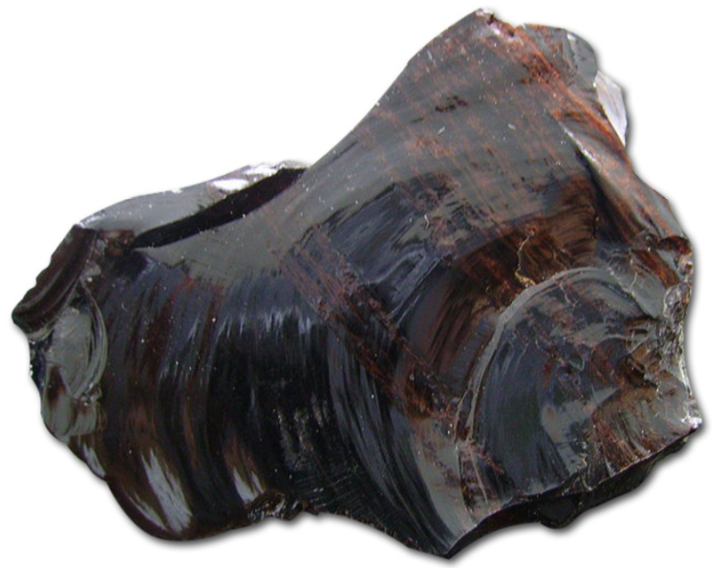
Cleavage OR Fracture | Cleavage OR Fracture
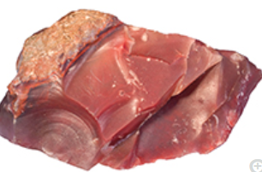 | 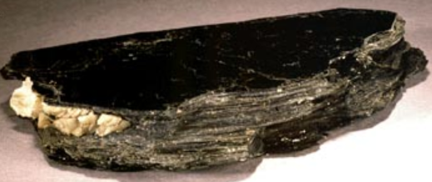
Cleavage OR Fracture | Cleavage OR Fracture
Igneous, Sedimentary or Metamorphic & WHY?

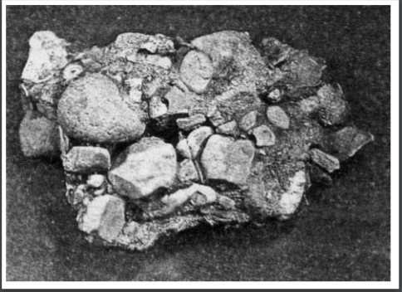 | 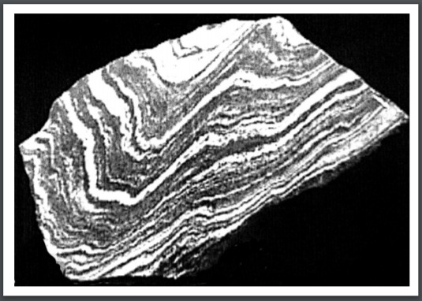
Igneous OR Sedimentary OR Metamorphic | Igneous OR Sedimentary OR Metamorphic
WHY? | WHY?
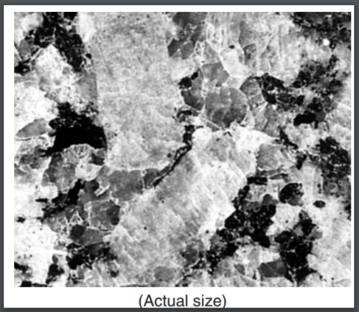 | 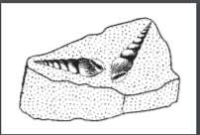
Igneous OR Sedimentary OR Metamorphic | Igneous OR Sedimentary OR Metamorphic
WHY? | WHY?
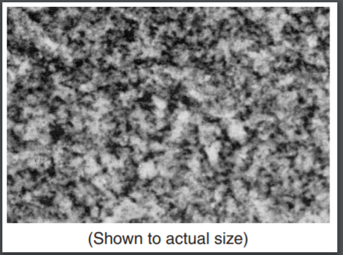 | 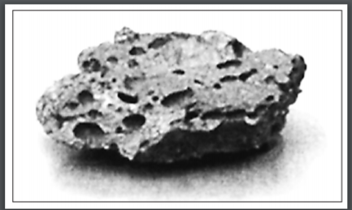
Igneous OR Sedimentary OR Metamorphic | Igneous OR Sedimentary OR Metamorphic
WHY? | WHY?

