Lesson: Latitude & Longitude

I Can…/Main Ideas Notes

Name the special

lines of Latitude

(Name & Degrees)

Explain what

Latitude is & what

measures how ____________ or _____________ of the _________________ you are.

Also known as __________________ – never cross

“Lat is _____________”

Latitude is ______________ to the _______________

of _________________ (_____________ Star)

in the _____________ Hemisphere Latitude = ____

Longitude lines measure ____________ & ___________ of the _______ _________________

Also known as _______________ – meet at the __________

Draw how Longitude lines look on a globe.

__________________________ = ______°

_________________________________ = ______°

**Remember:**

1. List ____________________ first
2. Latitude is _____ or _____
3. Longitude is _____ or _____

compass direction

it is measured in.

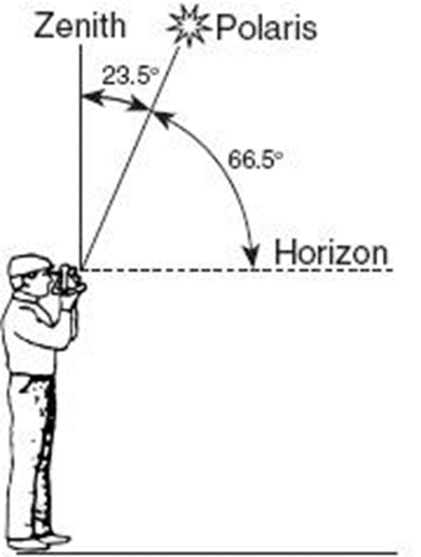

Name of the star

that helps find

latitude in the

Northern

Hemisphere

Explain what

Longitude is & what

compass direction

it is measured in.

Name the special

lines of Longitude

Locate places on

a map using latitude

and longitude

Lesson: Time Zones

I Can…/Main Ideas Notes

The world rotates (spins) ________° in ________ hours.

_______ ° / __________ hours = _________° per hour

The world has ________ time zones, each _________° apart.

**THERE IS A _______ HOUR TIME DIFFERENCE FOR EVERY ______° OF __________________**

Greenwich, England (______________________, 0°) is the logical starting point

* The world rotates _________ to _________ (_____________________), time zones to the east are ____________ of the time zones to the west



As you go ____________ time will _______________

As you go ____________ time will be ________________

Explain how far

apart each time

zone is & why.

Remember the

saying to help with

whether or not

to add or subtract

time.

Lesson: Topographic Maps

What is a topographic map? __________________________________________________ _______________________________________________________________________

Contour Lines: ____________________________________________________________ _______________________________________________________________________

Contour Interval: __________________________________________________________ _______________________________________________________________________

Stays the same for the whole map!

*Calculating the Contour Interval*:

1. Find 2 known lines
2. Find the difference between the lines

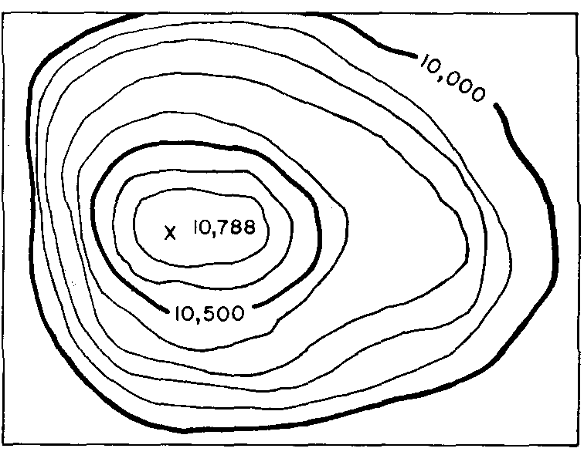

1. Count the number of lines
2. Divide the difference by the number of lines
3. Find 2 known lines ______ ______
4. Find difference between lines _____
5. Count # of lines between lines _____
6. Divide Step 2 by Step 3 __________

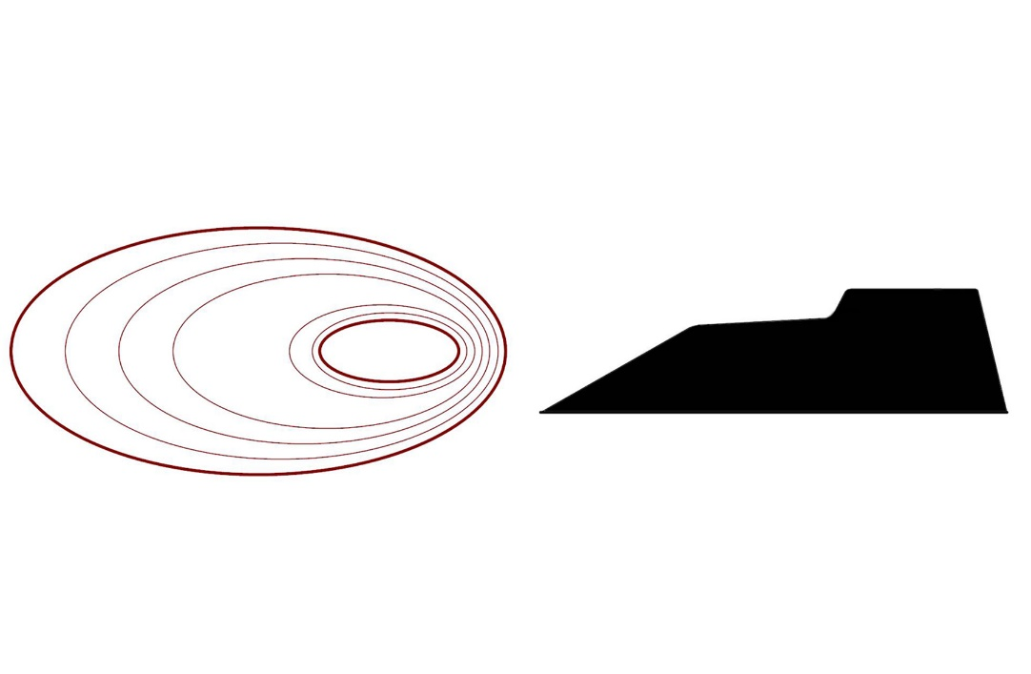

lines far apart = lines close together =

______________ _______________

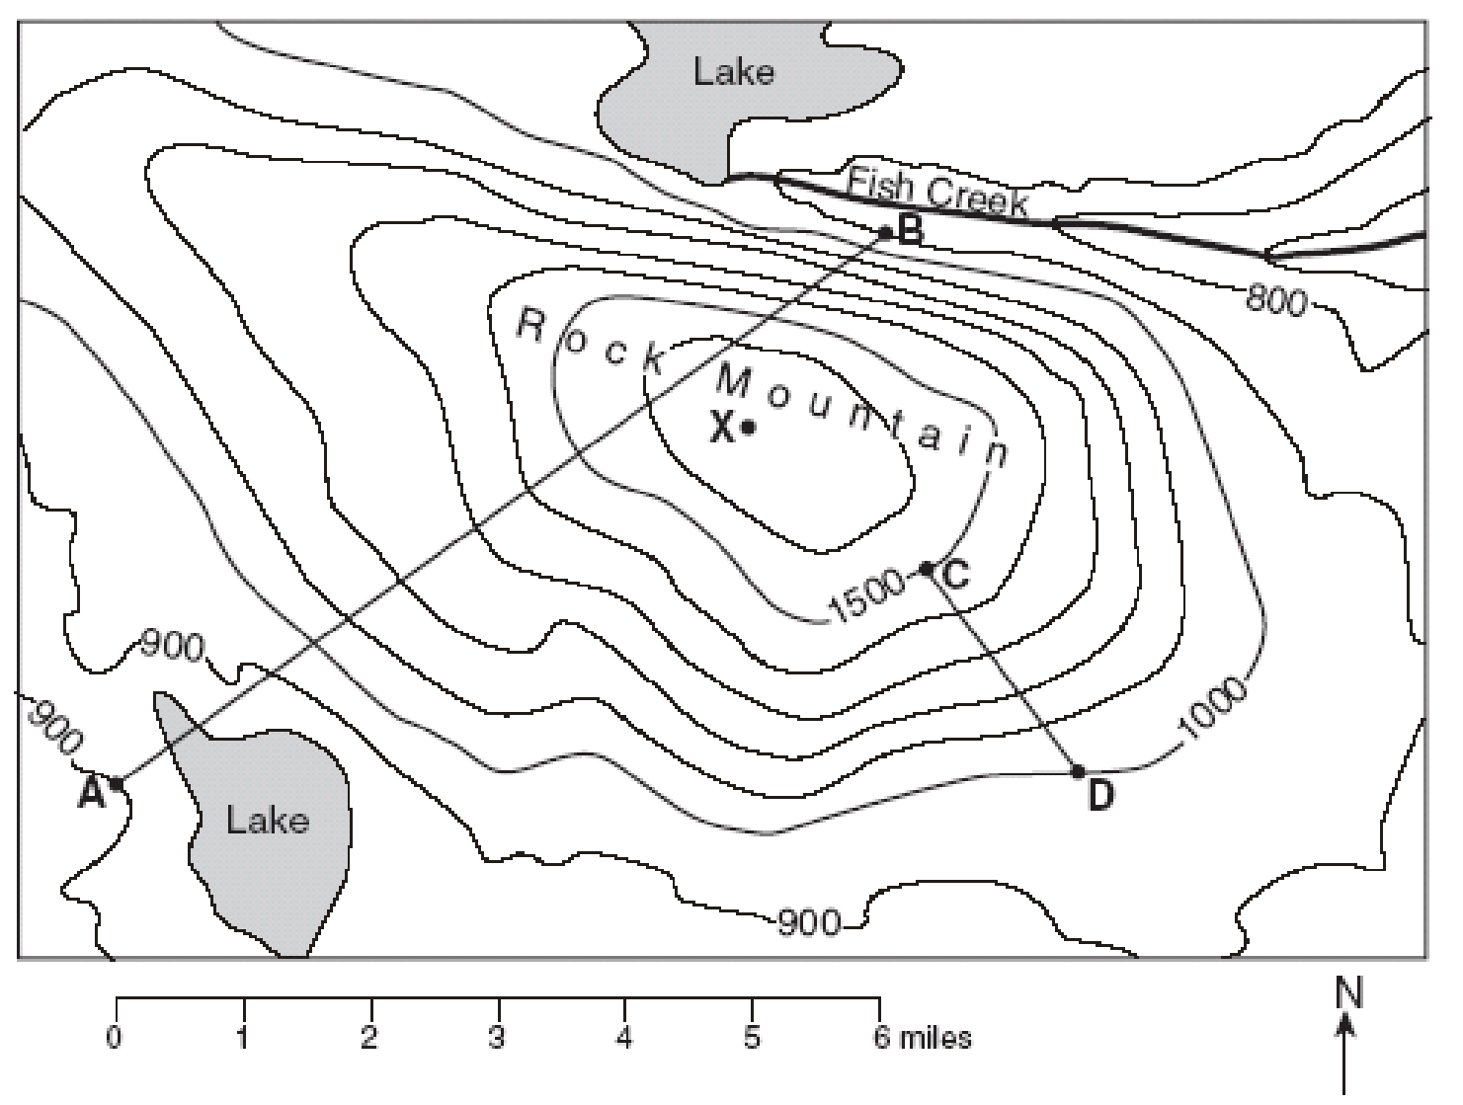

Gradient =

Calculate Gradient From C to D.

DIFFERENT PICTURE THAN IN THE VIDEO

Closed Circles = Closed Circles with hachure lines =

__________________ _______________________

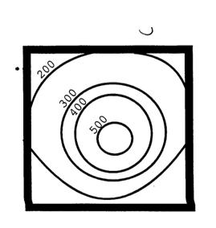 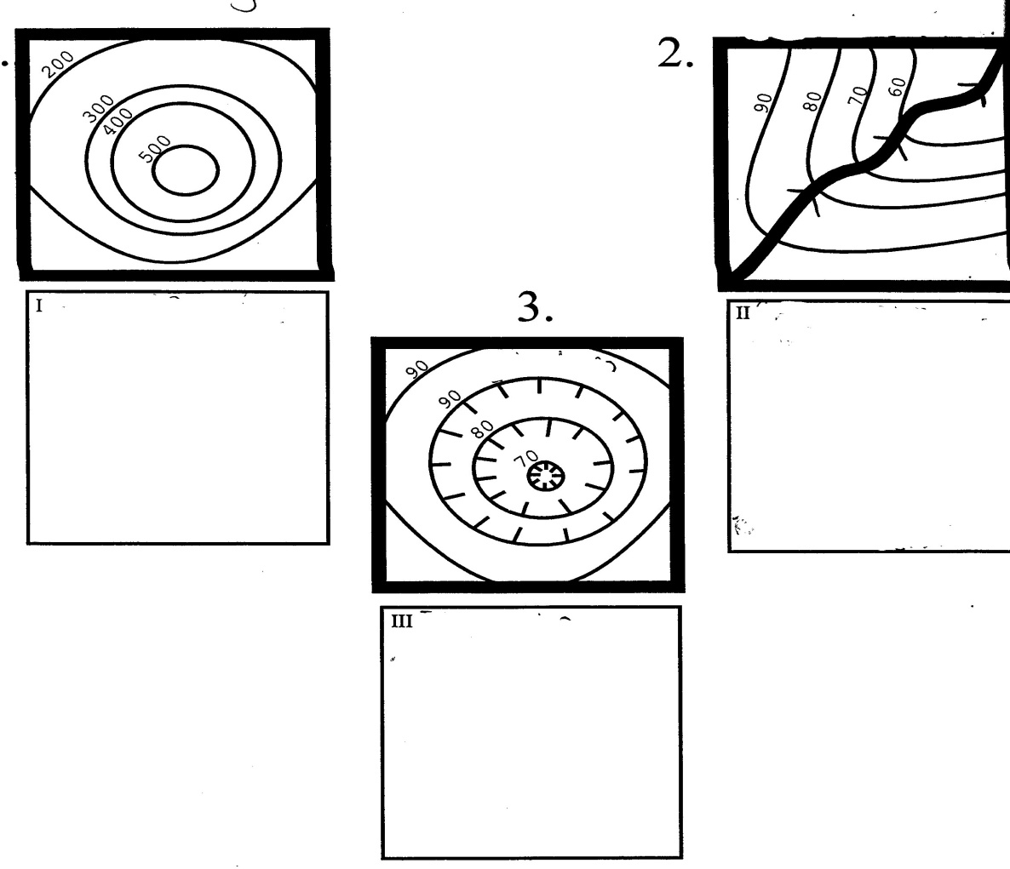

Contour Lines point ______________________________________________________!!!

[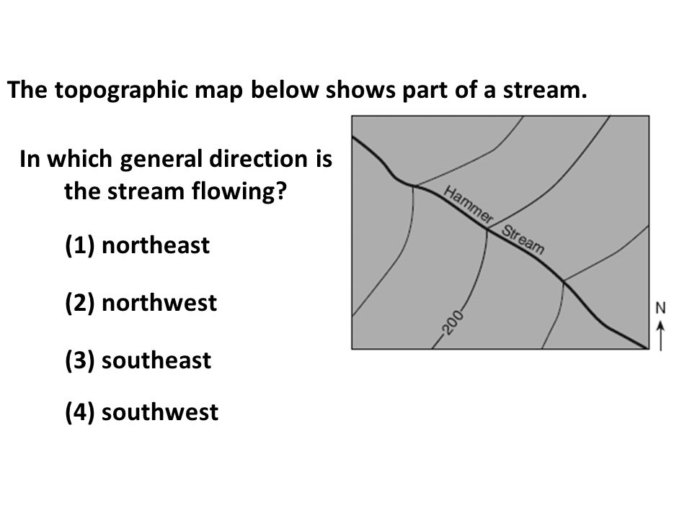](http://www.google.com/url?sa=i&rct=j&q=&esrc=s&source=images&cd=&cad=rja&uact=8&ved=0ahUKEwidx73xzKXPAhWDVT4KHcSpAigQjRwIBw&url=http://slideplayer.com/slide/2745496/&psig=AFQjCNEUEYQ5f47x5Uu9AHpFY5TE1qIRQw&ust=1474723915713955)

In which general direction is the stream flowing?

1. Northeast
2. Northwest
3. Southeast
4. Southwest

*Getting the highest elevation*:

1. Find the highest contour line on hill
2. 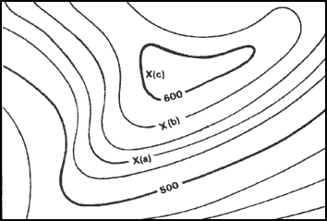Add the contour interval
3. Subtract 1
   1. What is the highest contour line? _________________________
   2. What is the contour interval?_______________
   3. Add the contour interval _________ + _________= _________

DIFFERENT PICTURE THAN IN THE VIDEO!

* 1. Subtract 1 = _____________

Topographic Profile: ________________________________________________________ __________________________________________________________________

Drawing Topographic Map Profiles – ***TRY THIS!!***

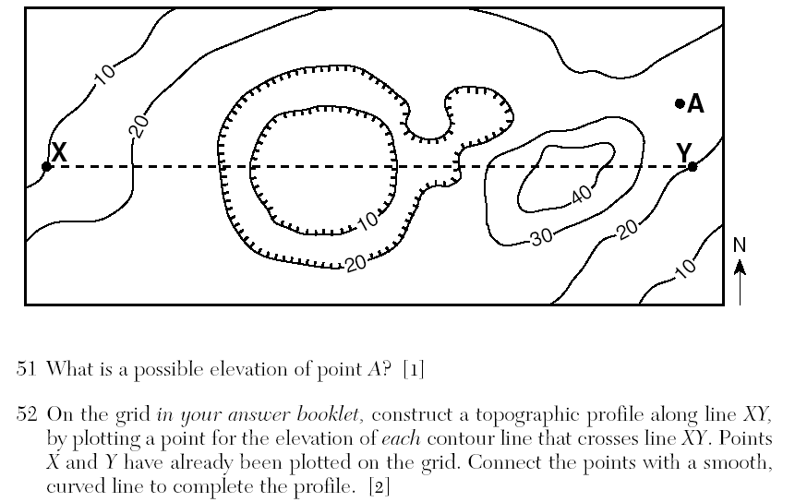

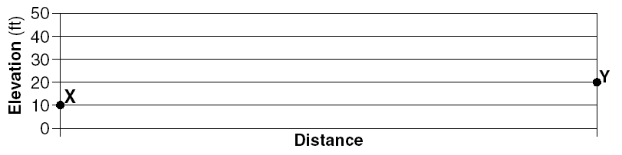

1. Label each contour line that intersects the straight line with the proper elevation just above the line.
2. Put the straight edge of a piece of paper up against the straight line on your map. Make a little mark on the edge of your paper every place where there is an intersection & write the elevation.
3. Place the edge of the sheet of paper you marked up against the x-axis. Plot each point on the graph at the correct elevation directly above each mark & connect them with a curved line. *When showing a dip or a rise in the land, curve your line slightly above or below the graphing line.*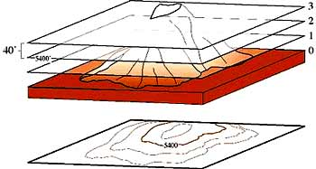



PRACTICE: - ***NOW YOU TRY!!!***

C:\Users\Melissa\Documents\Scanned Documents\Image (15).tif

110

100

90

80

70

60

50

40

30

20

|  |
| --- |
|  |
|  |
|  |
|  |
|  |
|  |
|  |
|  |
|  |

110

100

90

80

70

60

50

40

30

20

Lesson: Landscapes

I Can…/Main Ideas Notes

Landscapes are _______________ of ________________________

They are divided into 3 major types; by _________________, __________________, & _________________

* _____________________
* _____________________
* _____________________

**Mountains** - An area of ___________ elevation , **______________** gradient, and ____________________ rock structures (ex: ________ & ____________)

**Plateaus:** ______________ elevation, _____________ slope or ______________, & ____________________ layers

**Plains:** _____________ elevation & ______________ surface

I can explain the differences between the three main landscapes

|  |  |  |
| --- | --- | --- |
| **DENDRITIC DRAINAGE** | **TRELLIS DRAINAGE** | **RADICAL DRAINAGE** |
|  |  |  |
| – _____________ & _________________  (Rock layers are _________________)  -Branching similar to __________________________________ | * Where rocks of different hardness are __________________ or ________________ | – Occurs in _____________ structures (______________) with ____________ difference in rock ________________ |

I can illustrate the three main types of stream drainage patterns & landscape features associated with them

**ESRT** Pages _______ & ________

I can contrast uplifting & leveling forces

Uplifting forces - _____________________ forces

Start _____________ or **____________** Earth’s lithosphere where they make __________ rocks

* Example: ______________ action & Earthquakes

Leveling forces - ______________________ forces

Level out or **_____________** Earth’s surface by _________________ ______________ rocks

* Example: _________________, _________________, _________________, _________________

Arid climates –

* ________________ vegetation to

hold ________________

* ____________ slopes &
* ___________ _______________ landscape features

Humid climates –

* ___________________ holds

sediments in place

* ______________ & _____________

landscapes

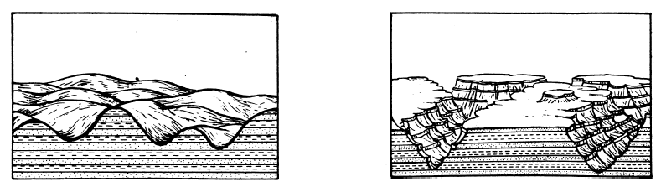

I can describe the effects of humid & arid climates on landscapes

