Chapter 9 – Earth In Space & Beyond Name: __________________________

Lesson: Origin of the Universe

I Can…/Main Ideas Notes

Universe - ______________________ that exists in any place.

(________ the space, matter & energy in existence)

Majority of scientists today believe the universe began with the ____________________

Gigantic explosion of matter which began to ___________________ ____________________________________________________

Universe believe to be ____________________________ years old

Solar system is about _____________________ years old.

1. ___________________________ tells us the universe is _________________________ and the ________________ expansion is ________________________
   1. ______________ = going ______________ from Earth
   2. ______________ = going ______________ Earth
2. Scientists can still detect ____________________________ __________________ from the Big Bang

Atoms cluster to become ___________

Stars & Planets are clustered in ___________________

Galaxies are collections of ______________ of ___________, ___________, and _____________ held together by ___________

I can describe how we

believe the universe

began

I can name the proof

for the big bang theory

I can describe red & blue

shift

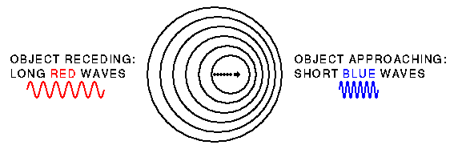

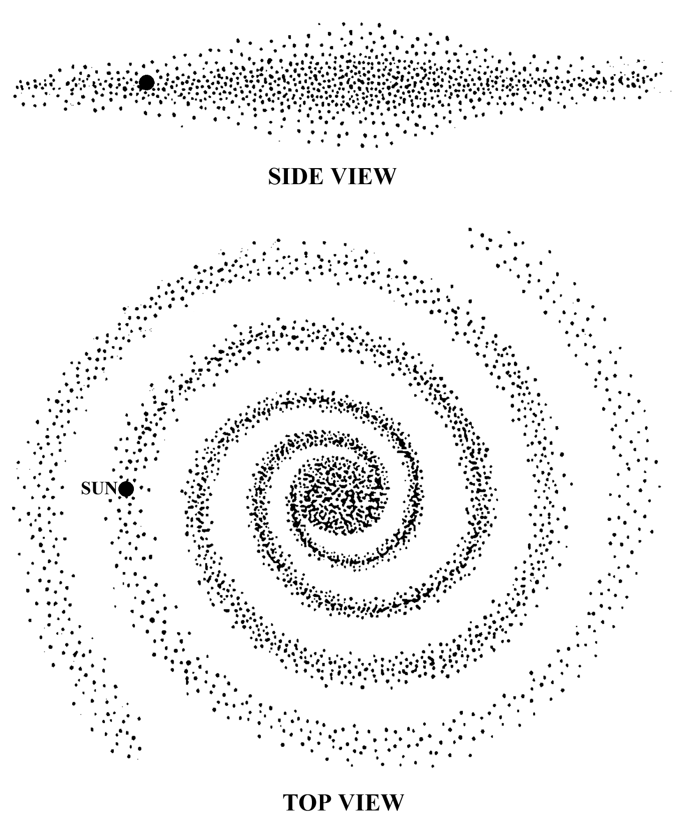Galaxies are

I can explain the

___________ Planets (ESRT pg ________)

Terrestrial (______________) _______________, ___________, ________________ and __________________

Jovian (_________________) _______________, ____________, ________________ and __________________

__________% of the Mass of the Solar System is the __________

__________% is _________________

__________% is __________________________

1. Asteroids: _______________________________________ ______________________________ between __________ & ____________
2. Comets __________________________________________ ________________________________________________

When either one hits the planet it creates impact _______________

1. Meteor __________________________________________ ___________________________________________ also called __________________________

* Appears as a ___________________________________

Universe is ________________________ light years across & ______________________________!

Light Year - ___________________________________________ _____________________ (about ______ trillion km)

A star is a ___________, _______________, ____________ body

Luminosity is the amount of _______________________________ ____________________________________________________

differences between

terrestrial & jovian

planets

Other Satellites

orbiting our Sun

Light Year

Lesson: Characteristics of Stars (NEARPOD – IN CLASS)

I Can…/Main Ideas Notes

I can define luminosity

How do stars differ?

1. ____________, ___________________, and ________
2. ______________________________________________
   1. Depending on __________________________to Earth
   2. Changes due to ________________________________ and because they ______________________________
3. Luminosity is compared to the __________ which = _________
4. Roughly _______% of all stars fall on a __________________ __________ across the diagram called the _______________ __________
5. Temperature _________________ as you move to the ______
   1. Blue = _____________ & Red = ______________
6. Mass of stars is directly related to ___________________

(Mass Increases than _______________________________)

The sun is a mass of _________________ and ______________ gas

The incredible ___________________ causes _________________ __________________, which creates all of the Sun’s energy

The sun is the ____________________ of _____________ energy.

Geocentric Model – All the planets, the sun & the moon revolve around a _________________________________________________

Heliocentric Model – Helio = __________ Centric = ______________

Nicolaus Copernicus ________________ this new model in ________

A major evidence to support Heliocentric theory - _______________ _________________ and _________________________________

Therefore:

Earth is **closer** – brightness & diameter appears to _______________

Earth is **far away** – brightness & diameter appears to ____________

I can read the H-R Diagram

I can explain how the sun creates energy

Models, Rotation & Revolution

I Can…/Main Ideas Notes

I can describe the

difference between

Geocentric & Heliocentric

model

I can explain why

apparent brightness &

diameter change

I can describe how fast

Rotation is the _______________________________________

It occurs at a speed of ______________ from __________ to ______________ (_________________________)

Indirect Evidence of Earth’s Rotation

1. __________________________________________
2. __________________________________________

Focault hung a heavy, long pendulum from a dome. If the Earth didn’t rotate, the pendulum would not rotate throughout the day. Focault’s pendulum turned 360º in one day, proving that the Earth rotates.

Coriolis Effect – As the Earth rotates, the paths of the winds & ocean currents __________________.

* Northern Hemisphere curve to the _______________
* Southern Hemisphere curve to the _______________

Earth ___________________ around the sun once every _________ days in a _________________ direction. About _______ per day.

Evidence:

1. _______________________ of Earth’s axis
   1. Earths axis always points towards _______________
2. _____________________________
   1. Apparent shift of _____________ of a star as we move __________________ and than ___________ away from the star.
3. _____________________________________________ with the seasons.

we rotate & in what

direction

I can state the evidence

for rotation

I can describe proof for revolution

Lesson: Earth’s Shape & Orbit

I Can…/Main Ideas Notes

Evidence for Earth’s

1. _____________________________ from outer space
2. ______________________ of the Earth on the Moon during an ________________
3. _________________________________
   1. Gravity is the _________________ of attraction between any __________________________.
      1. **Bigger** the object - _________________ the pull
      2. **Closer the centers** of the two objects the __________________ the pull
4. Ships appear to _____________ as they sail away from the __________________
5. The altitude of ____________________ changes with a person’s _______________________
   1. If Earth was flat the altitude of ______________ would NOT change

_______________________________ - the Earth ____________ at the Equator and is slightly _____________________ at the Poles

*Always choose the __________________ & __________________ object or drawing for Earth’s shape.

Gravity depends on ________________ and _________________

Newton’s Law of Gravitation- Objects close to the focus have

* ________________________________________________
* ________________________________________________
* _________________________________________ (revolve) around the sun

shape

I can name the shape of

the Earth

I can describe gravity

**LABEL THE PICTURE**

**LIKE IN THE VIDEO**

I can explain gravity’s

A _____________________ is any object that ________________ around another object.

It’s ___________________ that keeps the planets & all satellites in _____________________

Earth’s orbit is an ________________________

* There are _________________________ in an ellipse
  + Plural of focus - ________________________
  + One focus may be ______________________

*An ellipse is much like a ___________________________________*

Law #1: All planets move around the sun in _____________________ __________________

_______________________--> the shape of an ellipse where _____ = a ______________________________ & _____ = a __________

_________________________ is a line drawn

through the __________ extending to either

end of the ellipse.

Law #2: A line joining a planet & it’s star

marks _______________ areas during

equal time

Planet is ______________ to the focus (star)

* __________________ orbital _______________ (speed)

Planet is ______________ to the focus (star)

* __________________ orbital _______________ (speed)

effects on an orbit

Earth’s Orbit

Kepler’s 1st law of

Planetary Motion

Eccentricity =



I can calculate

Eccentricity

**Practice: (SHOW WORK)**

I can explain Kepler's

2nd law of planetary

motion

Sun

**LABEL the Picture** 🡪

Earth

Aim: The Moon & Its Phases (NEARPOD – IN CLASS)

Things to Know….

1. __________________________________________________________________
   * That orbit (­­­­­­­­­­______________________) is tilted at ________________
   * It takes __________________________ to complete one full revolution
2. __________________________________________________________________
   * It takes _________________________ to complete one full rotation
   * Because the moon __________________ & __________________ at the ______________________ we only see the _________________ of the moon
3. __________________________________________________________________
   * It reflects the sun’s light
4. If the Earth were a ________________ the moon would be a ___________________

_____________ feet away!

Phases: Observing & Identifying

* The phase of the Moon we see from Earth depends on how much of the ____________ side of the Moon ___________ Earth.

[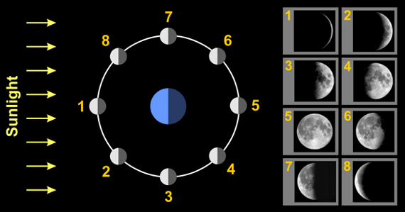](http://www.google.com/url?sa=i&rct=j&q=moon+phases+diagram&source=images&cd=&cad=rja&docid=eT2KzWdrV8XCXM&tbnid=JqGGQ0kO30c3qM:&ved=0CAUQjRw&url=http://astro.unl.edu/naap/lps/lunarPage2.html&ei=v2V8UZDkD-G_0AGWhoHgAw&bvm=bv.45645796,d.dmQ&psig=AFQjCNF58fL-BdGdrc198DiGV3_13r3Q0Q&ust=1367193015228400)

*Moon Phases*

* New Moon
  + During a new moon phase the side of the moon facing Earth _________________ _______________
* After the new Moon, the Moon ______, or the lighted side of the Moon you see ________. Remember the Moon revolves around the Earth ______________________
* Full Moon
  + The lighted side of the Moon that we see from Earth has reached its __________ The entire side of the Moon is ____________ from Earth.
* After the Full Moon, the lighted side of the Moon you see from Earth is getting ____________, or __________. The lit side of the moon we see is now on the ____________.

|  |  |  |  |
| --- | --- | --- | --- |
|  |  |  |  |
| New Moon | Waxing Crescent | First Quarter | Waxing Gibbous |
|  |  |  |  |
| Full Moon | Waning Gibbous | Third Quarter | Waning Crescent |

**Web Activity**:

1. Look up the phase of the moon on the day you were born. ________________________
2. What phase will the moon be in on your next birthday? _________________________

*Directions*: Draw & Label the moon phases shown below.



Lesson: Eclipses & Tides

I Can…/Main Ideas Notes

I can explain a solar

A solar eclipse is when the ____________ passes directly between the ____________________ and the ____________________

* Occurs during the ___________________________ phase
* Solar ____ ____ ___

Lunar Eclipse – Darkening of the

moon caused by the ___________

______________.

* Occurs during the

_______________________

eclipse & state the

order of the Earth,

Moon & Sun

[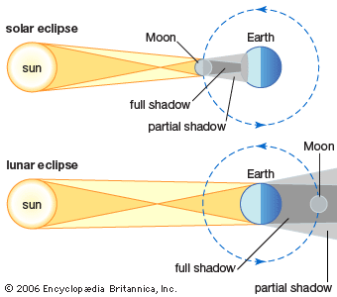](https://www.google.com/url?sa=i&rct=j&q=&esrc=s&source=images&cd=&cad=rja&uact=8&ved=0ahUKEwigr-bw9efTAhWILSYKHVkCBm4QjRwIBw&url=https://www.thinglink.com/scene/510129397307539458&psig=AFQjCNHy1tDguVQneajzlYu864RnQErTEg&ust=1494594773916969)

I can explain a lunar

eclipse & state the

order of the Earth,

Moon & Sun

[](https://www.google.com/url?sa=i&rct=j&q=&esrc=s&source=images&cd=&cad=rja&uact=8&ved=0ahUKEwigr-bw9efTAhWILSYKHVkCBm4QjRwIBw&url=https://www.thinglink.com/scene/510129397307539458&psig=AFQjCNHy1tDguVQneajzlYu864RnQErTEg&ust=1494594773916969)

Partial or Total lunar eclipses

* Caused by the different ____________________________
* ____________________ - center or the darkest part of the shadow
* ____________________ - outside or the lighter part of the shadow
* Lunar ___ ___ ___

Tides = the __________ & __________ of the waters of the earth

Caused by ___________________________________ of the ______________ & _____________

Spring Tides:

_____________ high tide & ____________ low tide

* Happens during a __________ & ___________ moon
* Sun, Earth & Moon are all in a ____(**S**traight line = **S**pring tide)
* Greatest _______________________________________

Neap Tide

Water changes ______________________

* Happens during the _________ & _________ ____________
* Sun, Earth, & Moon form a ______________________ (**N**inety degree angle = **N**eap tide)

I can state what causes

the tides

I can differentiate

between spring & neap

tides

[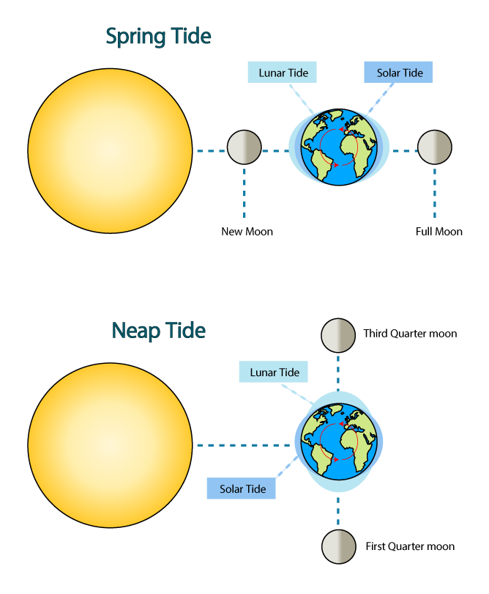](https://www.google.com/url?sa=i&rct=j&q=&esrc=s&source=images&cd=&cad=rja&uact=8&ved=0ahUKEwj5qNCI9-fTAhVG34MKHQ8PB1YQjRwIBw&url=https://www.education.com/science-fair/article/astronomy_moon-phase/&psig=AFQjCNFHMab8cktXoIXHtMlA8HOg16kA4g&ust=1494595125246640)

[](https://www.google.com/url?sa=i&rct=j&q=&esrc=s&source=images&cd=&cad=rja&uact=8&ved=0ahUKEwj5qNCI9-fTAhVG34MKHQ8PB1YQjRwIBw&url=https://www.education.com/science-fair/article/astronomy_moon-phase/&psig=AFQjCNFHMab8cktXoIXHtMlA8HOg16kA4g&ust=1494595125246640)